How to keep a fork up to date.

Here is how to keep a forked repo on GitHub up-to-date with its upstream GitHub repository.

A couple of days ago I forked the MaptimeMSP nacis2015-map repo, but today I go to GitHub and notice that I am 6 commits behind. I do a comparison

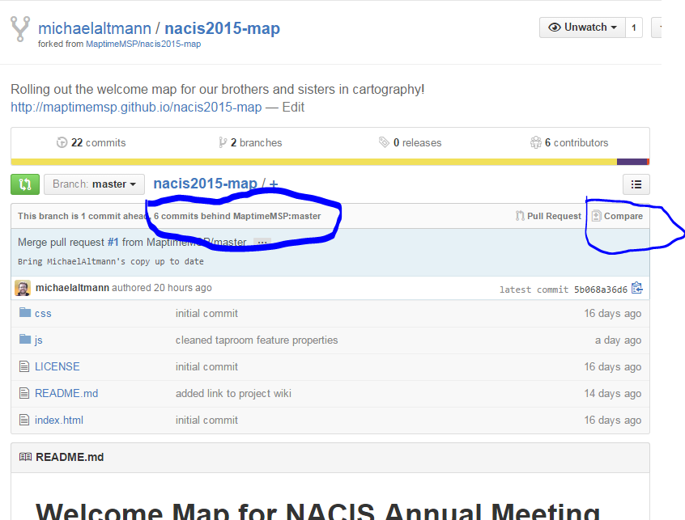

But it shows no changed files. I have to reverse the direction of the comparison [at one time I think I was able to do that with the button on the left, but now the button isn’t working to so I have to manually reverse them].
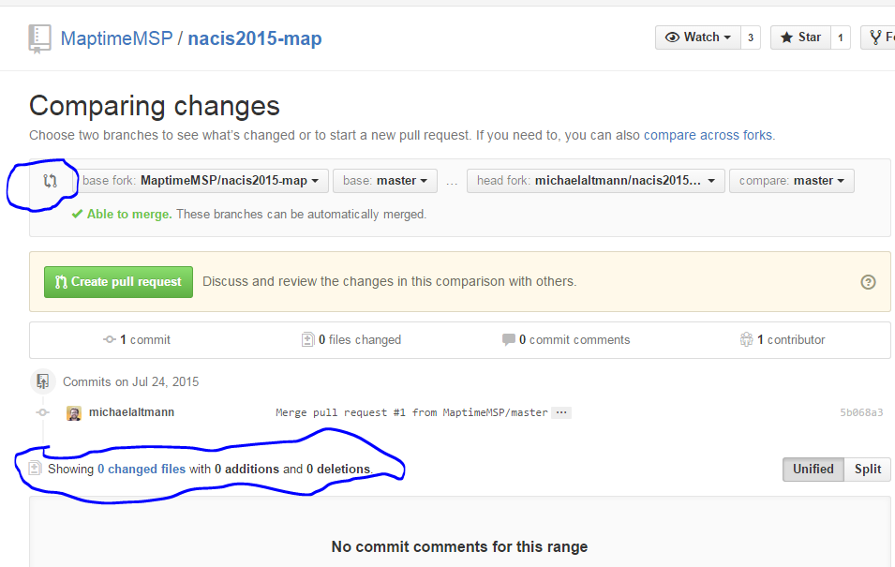

Lo and behond, there are the 6 changes to the MapTime version and an indication that I should be able to merge them to my repo smoothly. I initiate the merge by creating a Pull Request for myself.

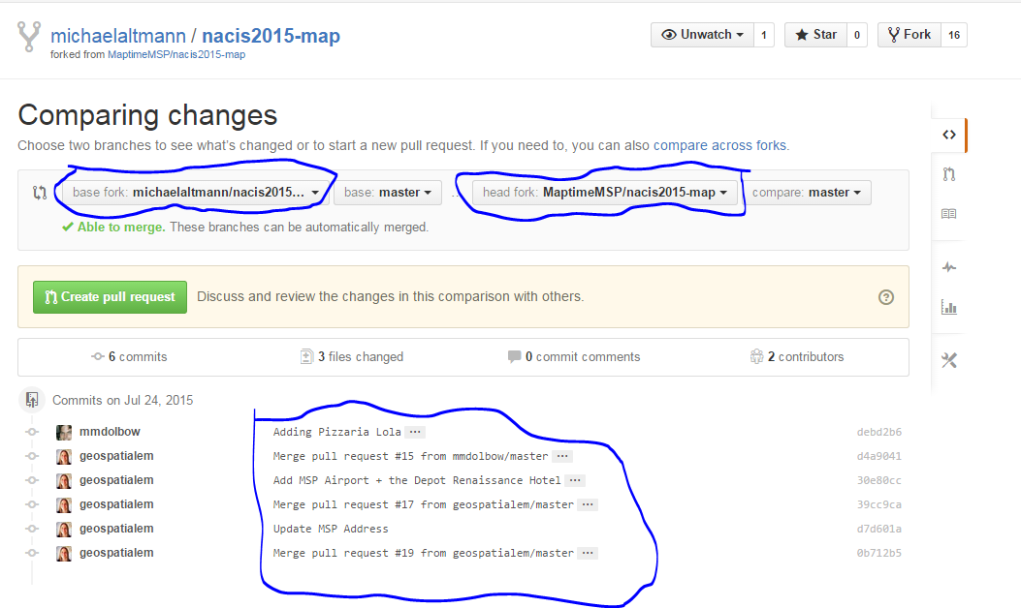

Sure enough, there is an open pull request and a button I will click to “Merge pull request”.
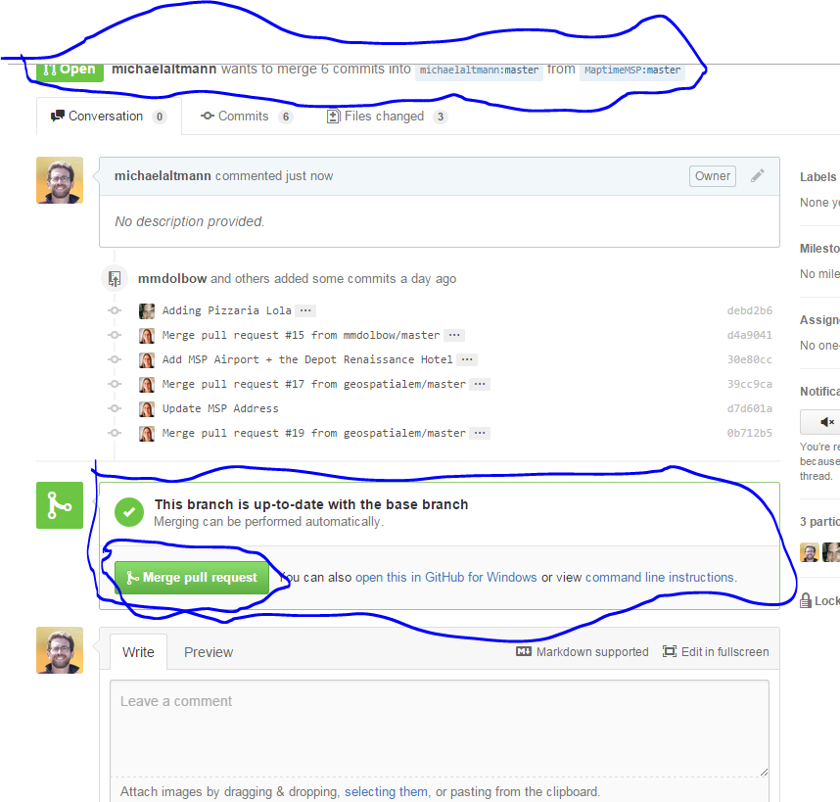

Notice my repo log has extra entries in the log that indicate where my merging occurred. I’m not sure if that will make it hard for MapTime when I submit a pull request.

